PROFORMA OF EVENTS

1.Name of the organiser: ALUMINI ASSOCIATION OF TULASI WOMEN’S COLLEGE, KENDRAPARA
2.Events: LAUNCHING OF MO COLLEGE ABHIJAN.
3.Date: 21.03.2021

REPORT
On 21.03.2021 “MO COLLEGE ABHIJAN” was launched by Govt. of Odisha in all Colleges across Odisha. The programme was also conducted in Tulasi Women’s College, Kendrapara on the same day. As part of the programme, an Alumni meet was conducted in the College premises by the Alumni Association Tulasi Women’s College. Prof. Ranjeet Ranjan Sahoo, Principal of the College inaugurated the meet. Around fifty alumnus alongwith local dignitaries attended the meet. The meeting was presided by Smt. Sulochana Nayak, President of the Alumni Association. Smt. Urmila Mohapatra, alumnus and the former Deputy mayor of Bhubaneswar Municipal Corporation and Smt. Sujatarani Kar, alumnus and member of Human Right’s Commission were also attended the meet and offer their valuable suggestions for betterment of the Institution and Alumni Association. During the interaction among alumni, the following feedbacks are offered by some of the alumnus.
- Time to time interaction among alumnus in regular intervals.
- To focus on fund raising for association activities.
- Fixing of a yearly membership fees.
- To plan/design services for betterment of present students.
- Observation of yearly Alumni meet.
- Organisation of different events.
- An open online forum to be created to interact and communicate with alumni to take valuation suggestions.

Lastly, the meeting ended with vote of thanks to the Chair and all the guests present. The Alumni Association express heartful gratitude to the Principal, Tulasi Women’s College and IQAC Co-ordinator for their guidance and support to make this event grand success.
NOTICE
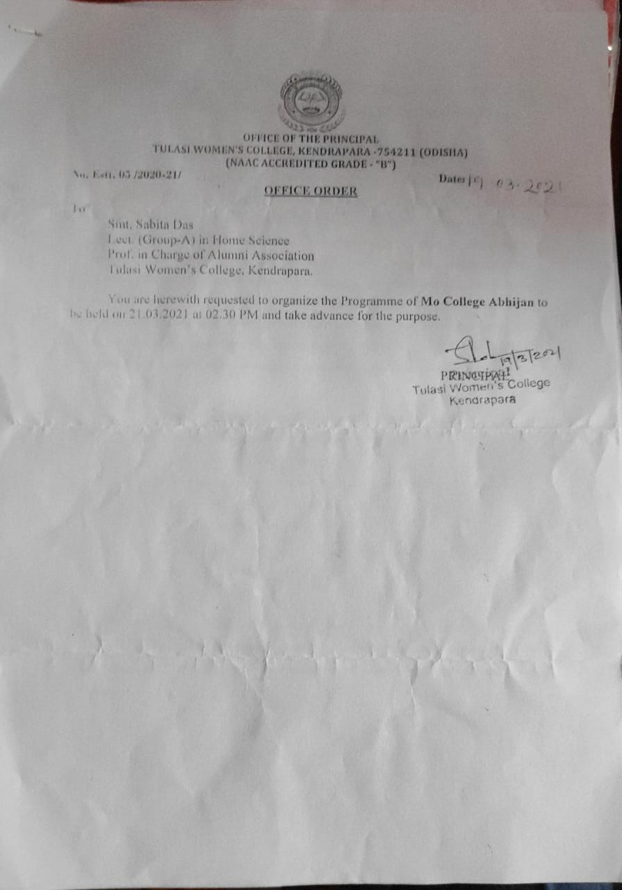

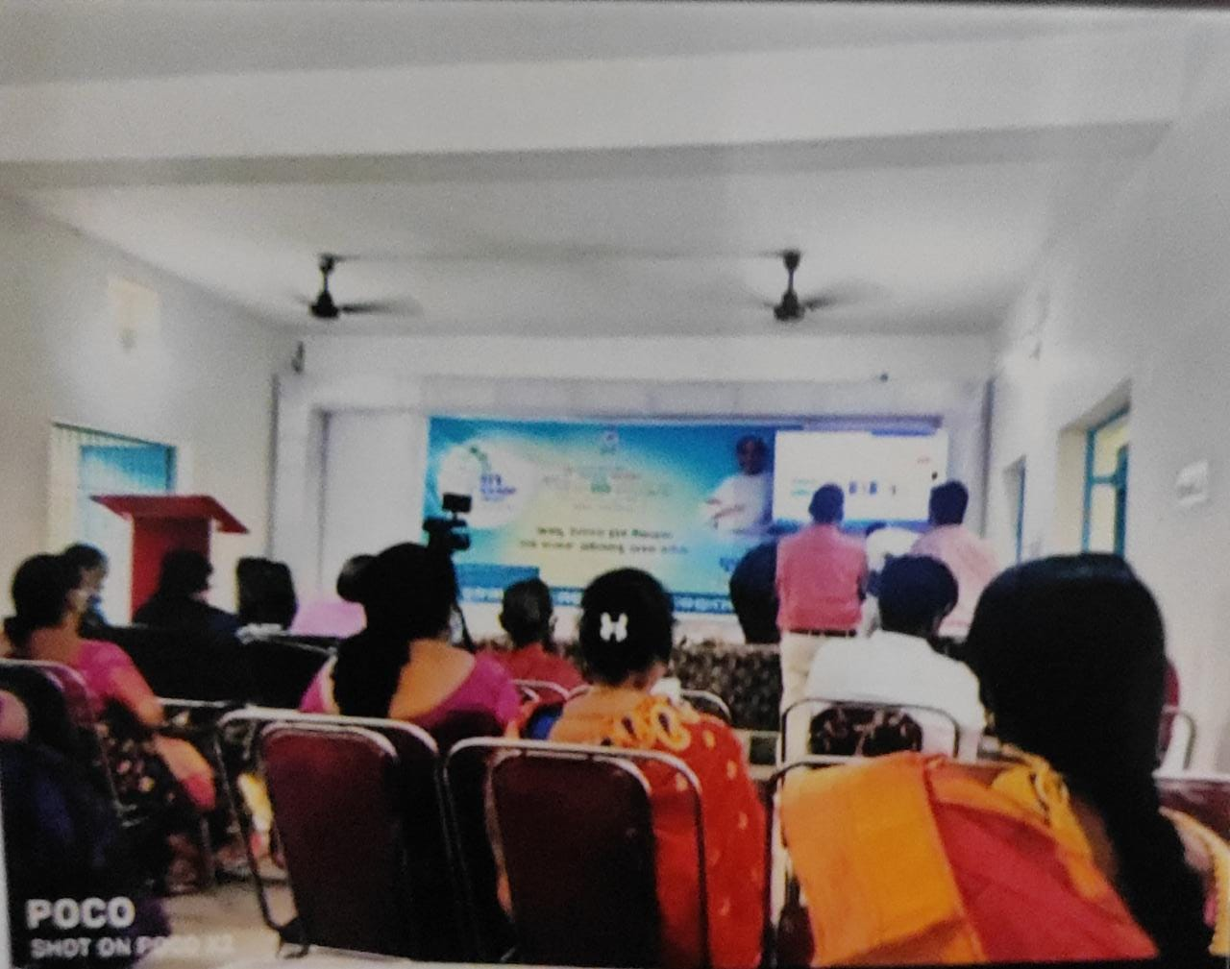
PHOTOS

