PERFORMA OF EVENTS: SEMINAR
- NAME OF THE DEPARTMENT: Department of Education
- EVENT: Seminar
- DATE: 10.03.2021 TIME-11 AM
- TITLE OF THE TOPIC: “Research and Publication Ethics.”
- NAME AND DESIGNATION OF THE RESOURCE PERSON:
Dr.PravakarMallick
Reader in Education
Kendrapara Autonomous College,Kendrapara.
Dr.PravakarMallick is presently working as a Reader in education at Kendrapara Autonomous College, Kendrapara. He has published no. of articles in National and international journals and attended no. of National and International seminars, workshops and symposiums. Besides these he has guided many students for research work. He is associated with many organizations for developmental activities in the field of Education.
- Abstract of the topic: Attached
- Any Other remarks:
Welcome speech and introduction of resource person was given by Miss JayashreeBehera,Lecturer in Education followed by address of resource person Dr.PravakarMallick on “Research and Publication Ethics”. More than 60 students and faculty members have participated in this seminar. The programme was ended with vote of thanks by Miss LizaraniPradhan,Lecturer in Education.

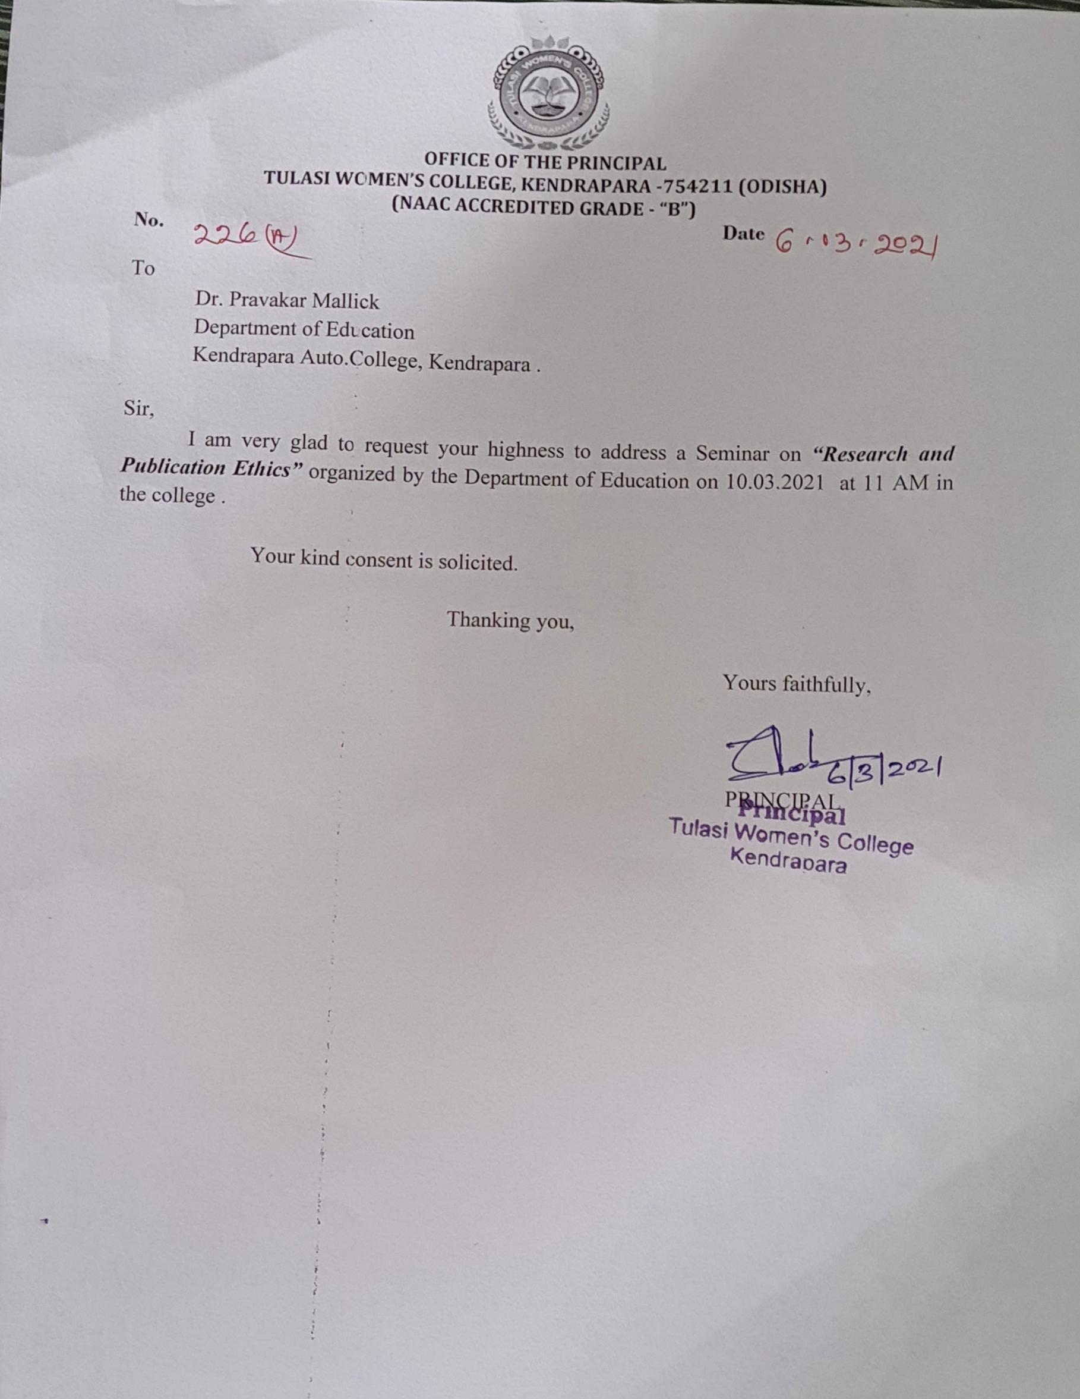

Research and Publication Ethics
Abstract:
Researchers,authors,sponsors,editors and publishers all have ethical obligations with regard to the publications and dissemination of the results of Research. Ethical codes not only help maintain scientific integrity but also safeguard the primary aim of conducting the research i .e to promote knowledge and truth. These ethical norms make researchers accountable for the quality and outcome of the research. With all the importance of ethics for the conduct of research, it should come as no surprise that many different professionals, associations, government agencies and universities have adopted specific codes, rules and policies relating to research ethics.

Dr.PravakarMallick
Reader in Education
Kendrapara Autonomous College, Kendrapara.

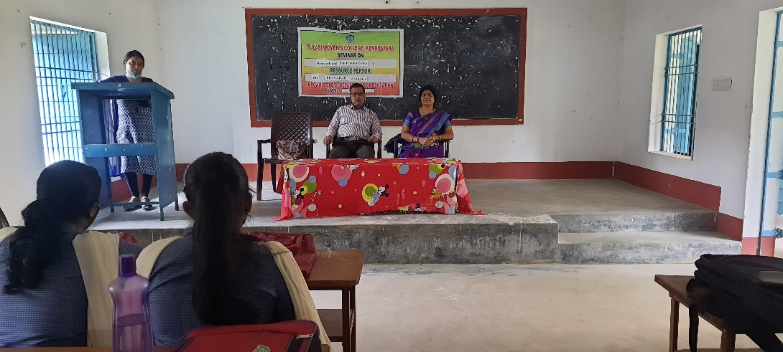
Photo:

