Curriculum Vitae
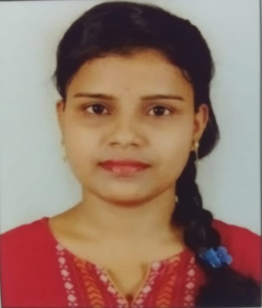
- Name: Miss Manasi Mohanty
- Department: Economics
- Designation: Lecturer in Economics
- Qualification: M.A and Mphil from Analytical and Applied Economics, Utkal University
- Email: manasimohanty34@gmail.com
- Area of Interest/Specialization: Advanced Econometrics and Financial Economics
- Publications in Journal/Chapters/Books: Nil
- Seminars/Conference/Workshop/Refresher Course/FDP: National seminar at Utkal University.
- Awards/ Honors/Fellowship/Research Project:
"Effect of BSKY scheme on Healthcare Utilisation and Out-of-pocket Expenditure: A case study in Kendrapada District".
- Professional Experience: Nil

